1. Download and install InnnoSetup

https://jrsoftware.org/download.php/is.exe

1. Open Butterworth/SampleFiltering.sln and build

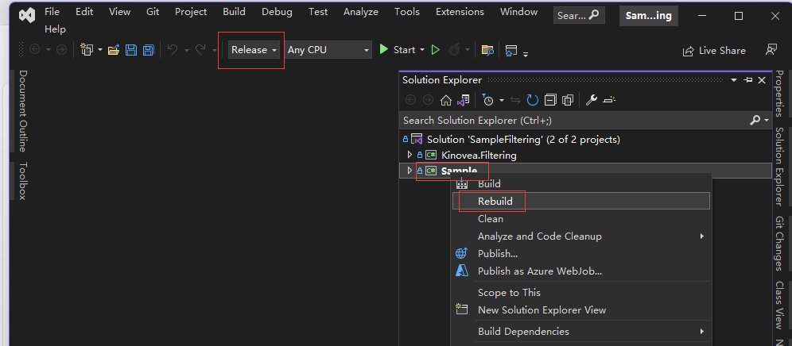

1. Open src/Chronojump.sln and publish

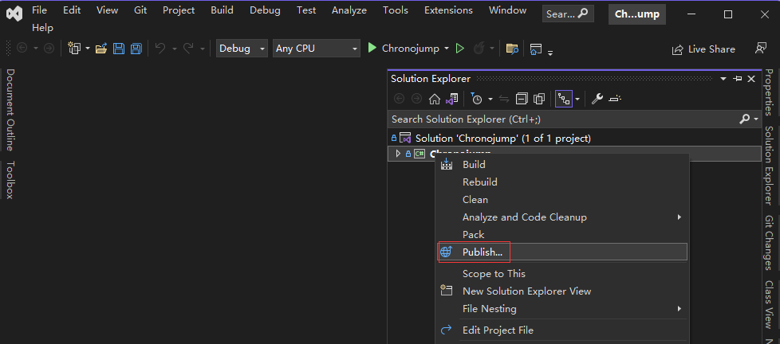

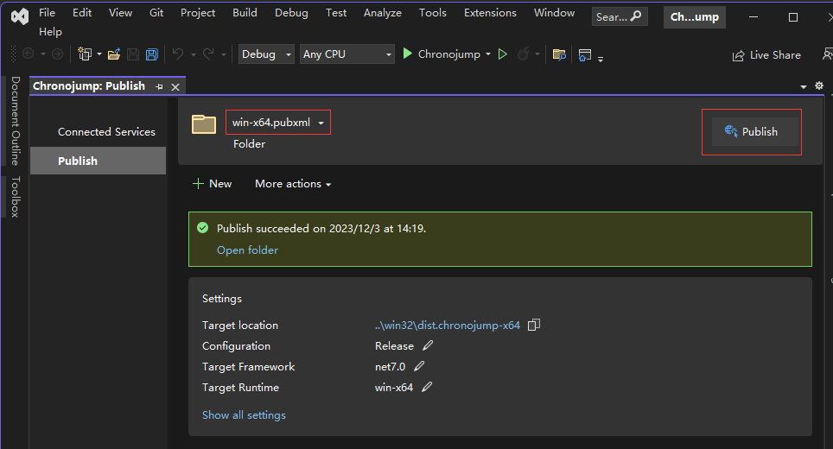

1. Run InnoSetup and choose iss script

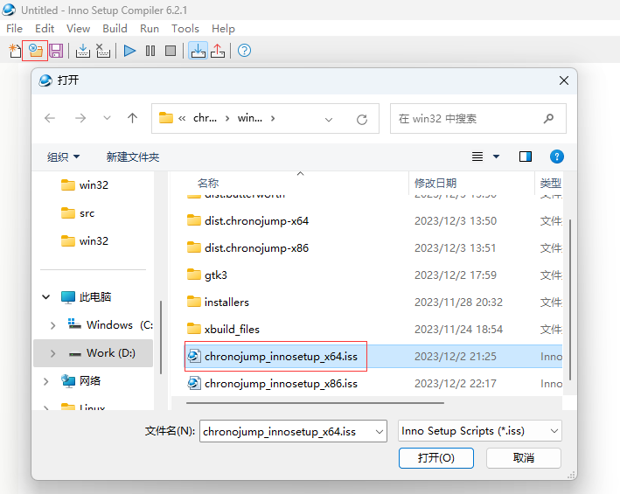

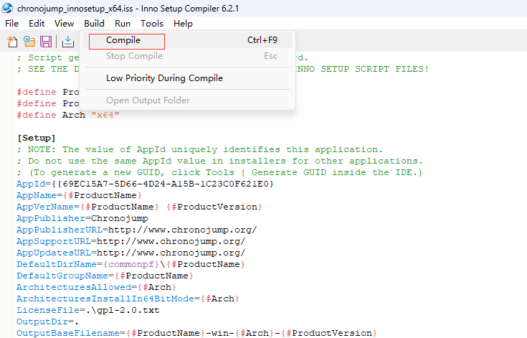

1. The Windows package named “chronojump-win-x\*\*-\*\*.\*\*.exe” locates in folder “win32”
2. How to update .NET runtime, Python, R and driver?

Download the latest installers and put them into folder “win32/installers”;

Modify iss script to replace the old ones.

